**Exercise #11:**

1. Count the number of employees who have been with Bignet for four or more years.

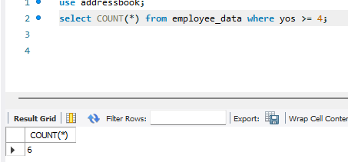

1. Count employees based on their ages.

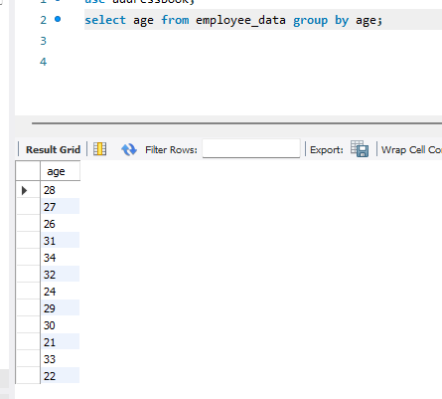

1. Modify the above so that the ages are listed in a descending order.

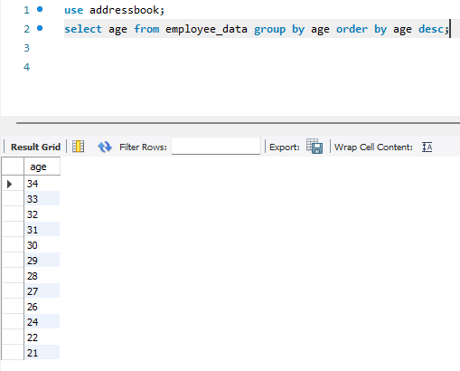

1. Find the average age of employees in different departments(titles).

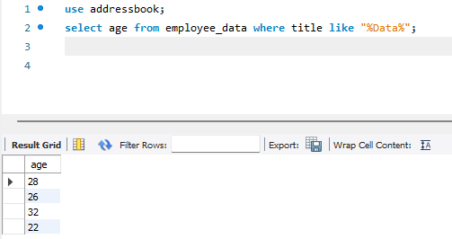

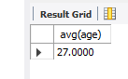

There is 4 in Data department with an average age of 27.

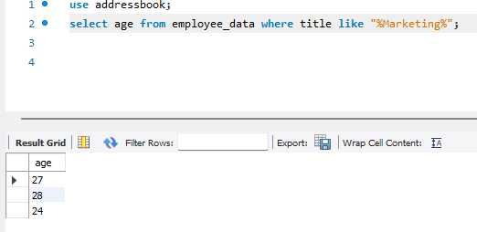

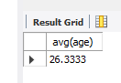

There is 3 in Marketing department with an average age of 26.

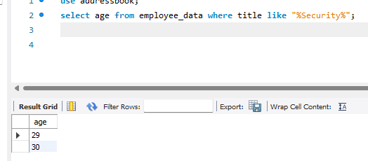

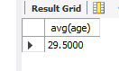

There is 2 in Security with an average age of 29.

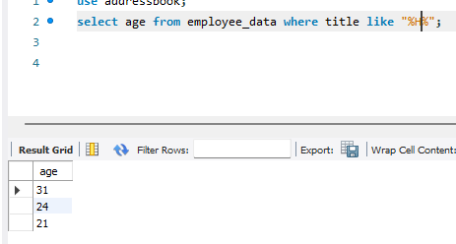

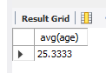

And there is 3 in HR/HE department with an average age of 25.

1. Change the above statement so that the data is displayed in a descending order of average ages.

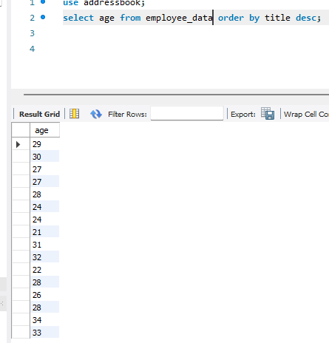

1. Find and list the percentage perk (perk/salary * 100) for each employee with the % perks sorted in a descending order.

